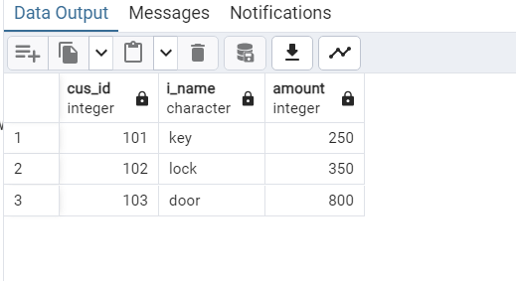
1day 2 internship

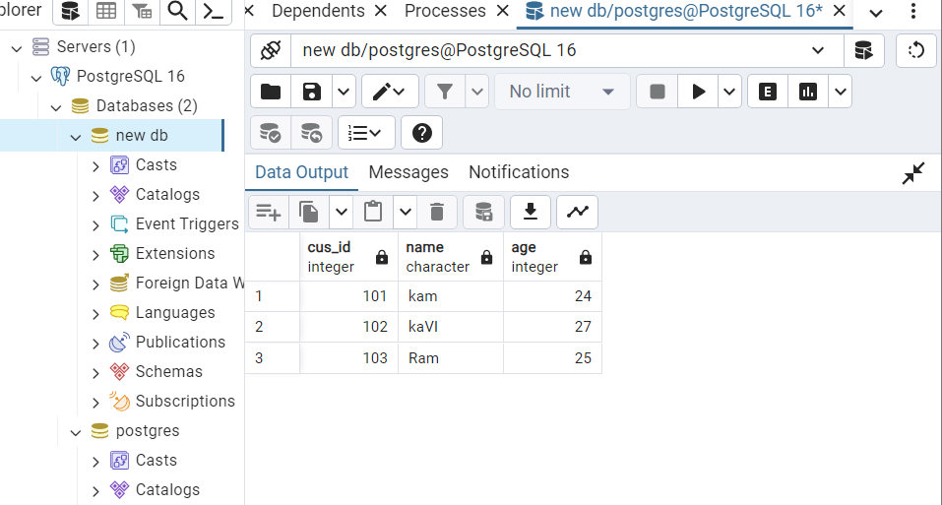
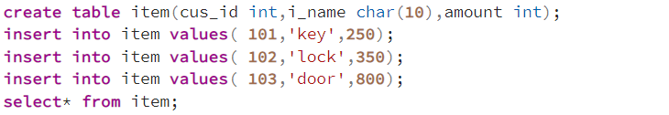

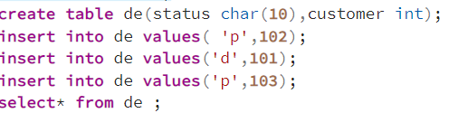

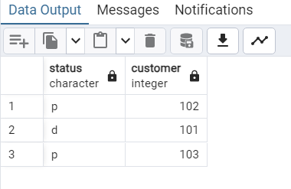

select cs.cus_id,item.i_name,de.status from cs join item on cs.cus_id= item.cus_id join de on cs.cus_id=de.customer;
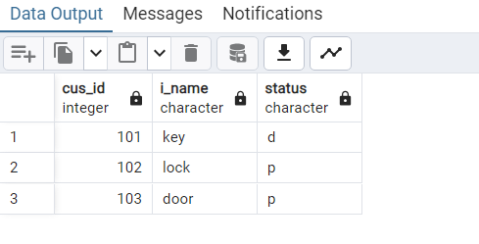

select cs.cus_id,item.i_name,de.status from cs join item on cs.cus_id= item.cus_id join de on cs.cus_id=de.customer where name ='kaVI';
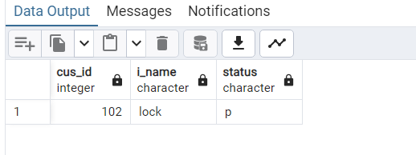

select cs.cus_id,item.i_name,de.status from cs join item on cs.cus_id= item.cus_id join de on cs.cus_id=de.customer fetch first 2 row only;

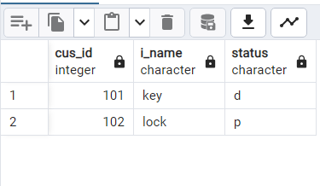

select cs.cus_id,item.i_name,de.status from cs join item on cs.cus_id= item.cus_id join de on cs.cus_id=de.customer limit 1;
